Bariki ya nafsil rabba

(Bénis l’Éternel, mon âme)

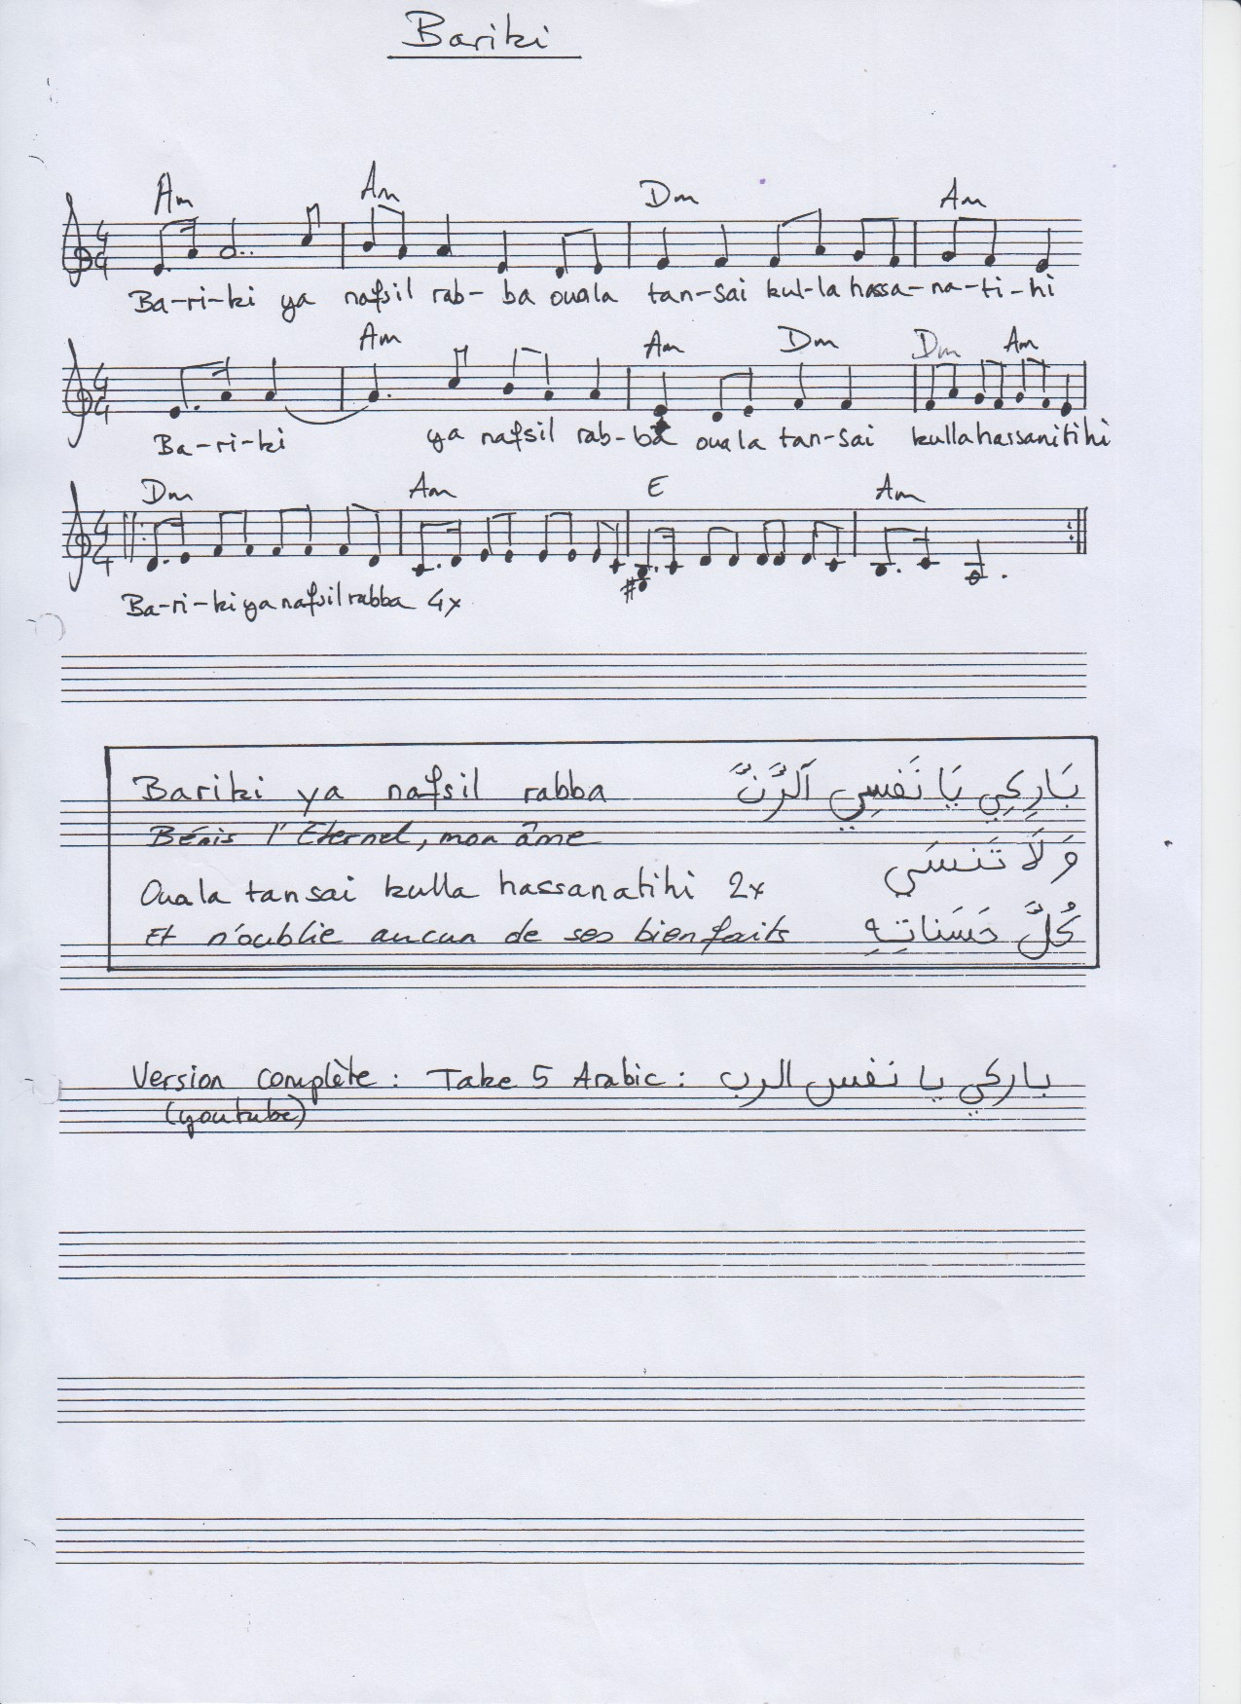

Bariki ya nafsil rabba  
ouala tansai kul hassanatihi [x2]

Bariki ya nafsil rabba [x4]