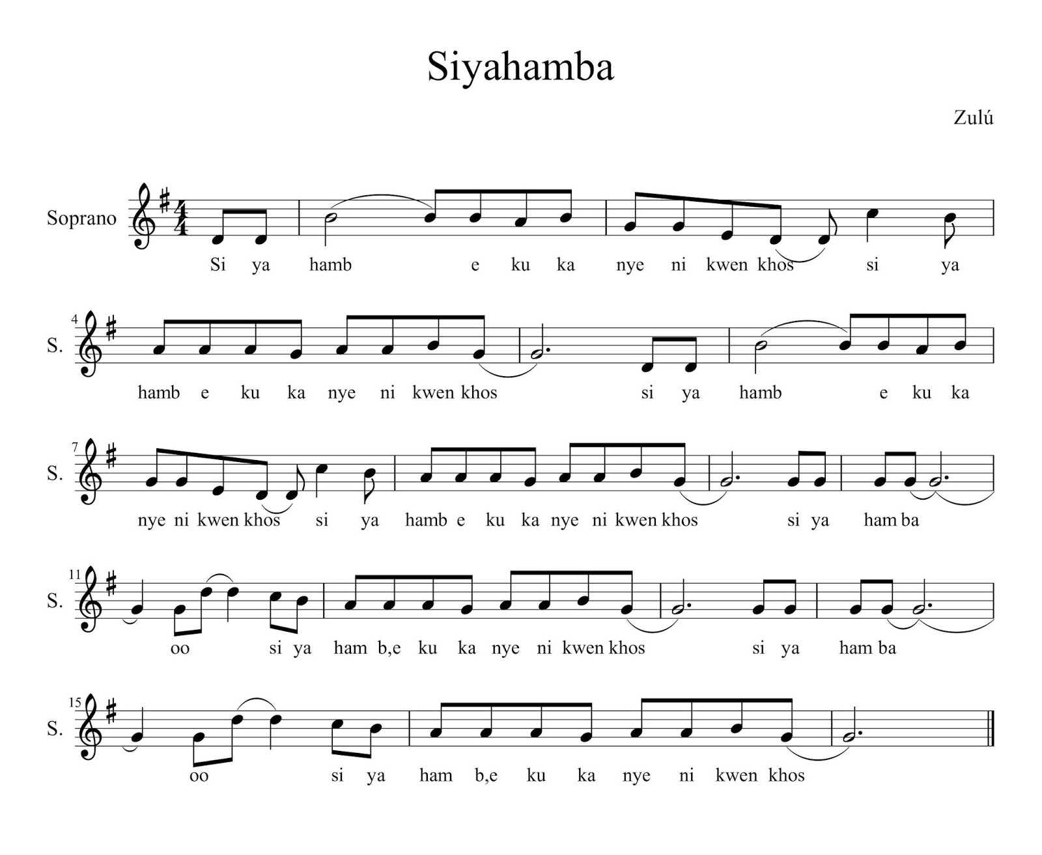

Siyahambe kukka nyeni kwenkos, siyahambe kukka nyeni kwenkos [x2]  
Siyahamba, hamba, siyahamba, Oh, siyahambe kukka nyeni kwenkos [x2]

Nous marchons dans la lumière de Dieu, nous marchons dans la lumière de Dieu [x2]  
Oui nous marchons, marchons, oui nous marchons, Oh, nous marchons dans la lumière de Dieu [x2]

We are marching in the light of God, we are marching in the light of God [x2]  
We are marching in the light of God, we are marching in the light of God [x2]